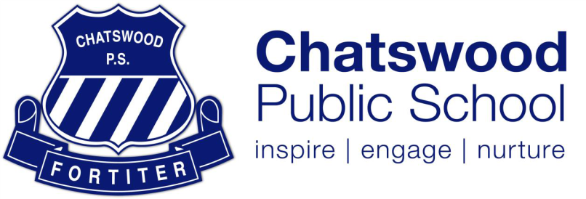

2020 Kindergarten English/ Korean Bilingual Program

Chatswood Public School successfully pioneered the English/Korean Bilingual program in 2016. In 2020, there will be 9 bilingual classes throughout the school where each class is comprised of 80% non-Korean background students and 20% Korean students. Bilingualism is proven to develop and improve cognitive and academic skills and help students to develop skills necessary for problem solving and innovative thinking. The bilingual stream will run from K-6 involving over 150 students in 2019. Through the use of the Content and Language Integrated Learning (CLIL) approach and the integration of Science, Technology, Engineering and Mathematics (STEM) activities, students are growing to become bilingual learners through subject-oriented teaching, real world applications and innovative learning. The bilingual program has helped students to develop flexible thinking and problem solving skills. It has increased the number of bilingual/multilingual students at Chatswood Public School. It has also had a significant impact on our students’ understanding of the world around them, which is growing them to become global citizens in the 21st century.

Students in the bilingual program have been achieving great results in both English and Korean. Students are engaged in English Literacy groups in the morning and students learn regular curriculum content in Korean for at least 5 hours per week covering the Key Learning Areas (KLA’S) of Mathematics, Science, History/Geography, Creative Arts. They also receive Korean language lessons once a week with the buddy bilingual class through team teaching. During these lessons, students learn about the technical aspects of the language of reading and writing and are introduced to new vocabulary and phrases through songs and interactive activities to ensure KLA’s are understood in Korean. Students are also involved in cultural experiences by participating in cultural activities, integrating Korean literacy, participating in traditional games and visiting the Korean Cultural Centre.

By the end of the year, students in Kindergarten are able to understand and respond to greetings, questions and instructions in familiar social interactions such as games, role-plays and classroom instructions. They are also able to read words and phrases in Korean and are developing writing skills in context. Students are developing pronunciation and intonation skills and are confidently participating in social exchanges with teachers and peers.

Parents are supported and involved in their child’s bilingual education through homework activities that correspond to their learning at school that week and audio files are emailed weekly to help with pronunciation and learning words and phrases together. There is also a Chatswood Public School Korean Bilingual Program YouTube channel where Korean phrases and songs learnt at school are posted. There is also a strong network of parents involved in the bilingual program that help support the group.
……………………………………………………………………………………………………………………………………………

Expression of Interest for 2020 Kindergarten English/ Korean Bilingual Program

Child’s name:  ………………………………………………………………... | Parents/ carers name/s:  ………………………………………………………………...
Email:  ………………………………………………………………... | Contact number:  ………………………………………………………………...
Date of birth:  ………………………………………………………………... | Ethnic Background/ Languages spoken at home:  ………………………………………………………………...

Please return to the office or via email to koreanbilingualcps@gmail.com by Monday 28th October 2019.

